Repurposed Furniture for Greenhouse | October 2022 | In furnishing the school greenhouse, the Environmental Club repurposed several pieces of furniture to keep them from landfills. A couch and several pieces of wood (for the aquaponics project) were taken from a dumpster and disinfected for use. A broken table from the Art Department was modified and now serves as the coffee-table-sized plant holder, which currently has tomatoes. | See below for pictures
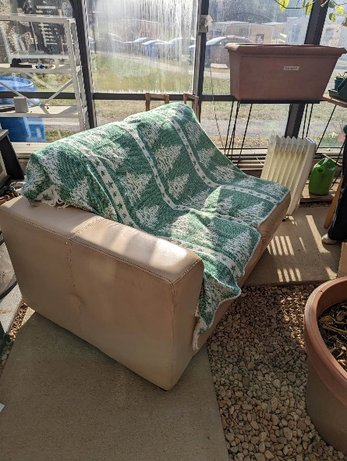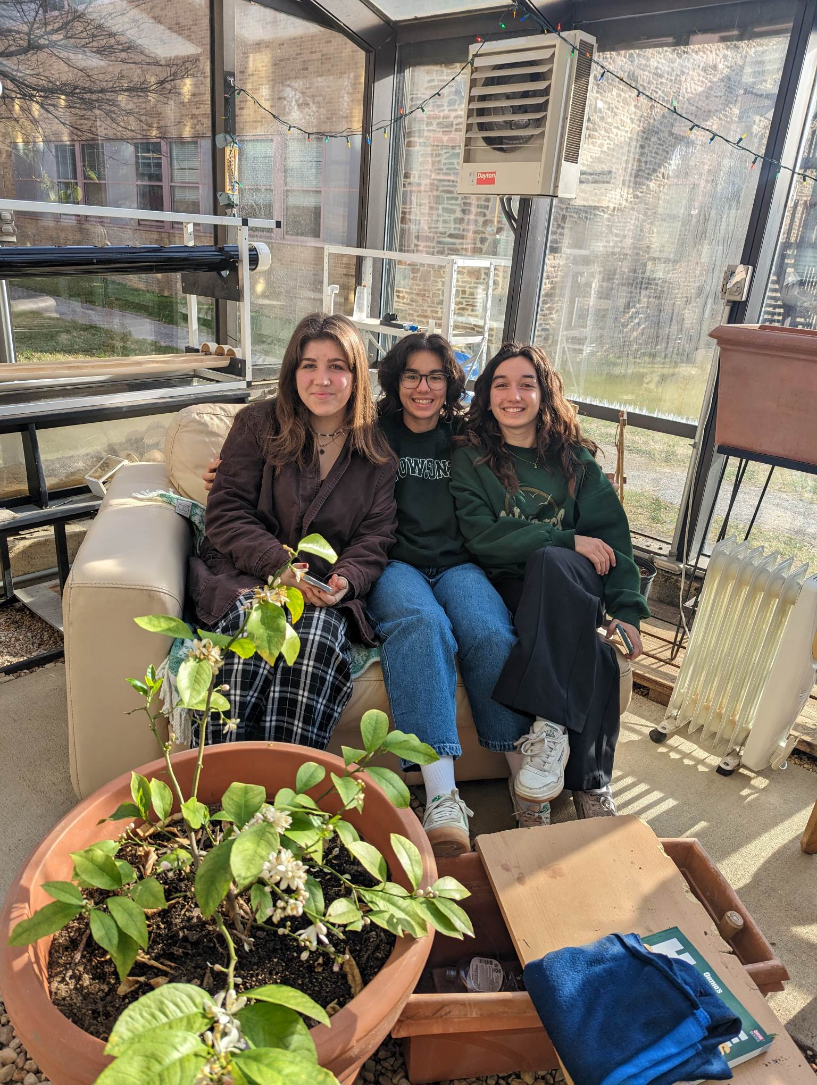
Students Georgia, Belize, and Sonya show off the repurposed couch they harvested from the dumpster. November 2022

